**ERD for the initial requirements:**

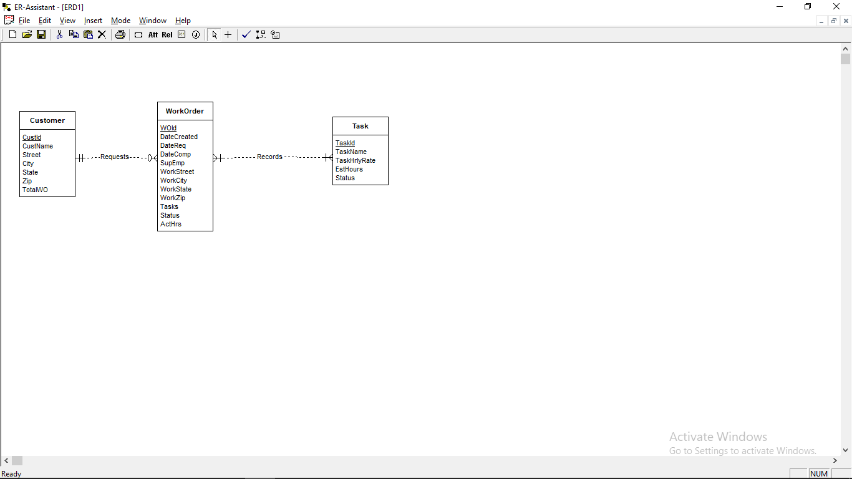

**Revised ERD:**

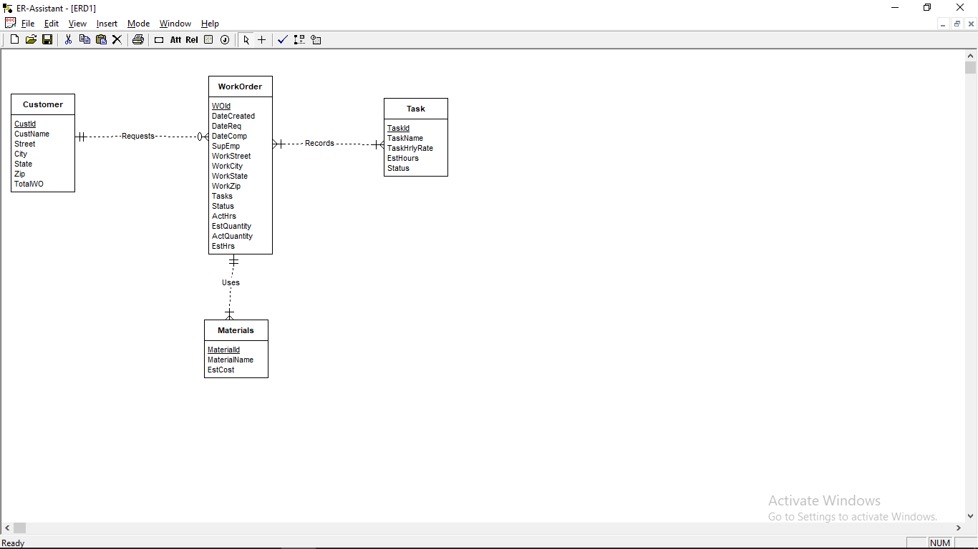

**list of design decisions for ERD:**

Identify the nouns to select as meaningful entity. The narrative provides incomplete details about some new relationships. The narrative indicates that a Customer can Request many Work Orders and a Work Order contains one Customer. However, the minimum cardinality specifications are omitted. The minimum cardinalities in the Request, and Uses relationships are not specified in the problem statement.

The problem statement needs another revision about the Work order process. The current design does not store details about materials so we add new entity named as Material in revised ERD.